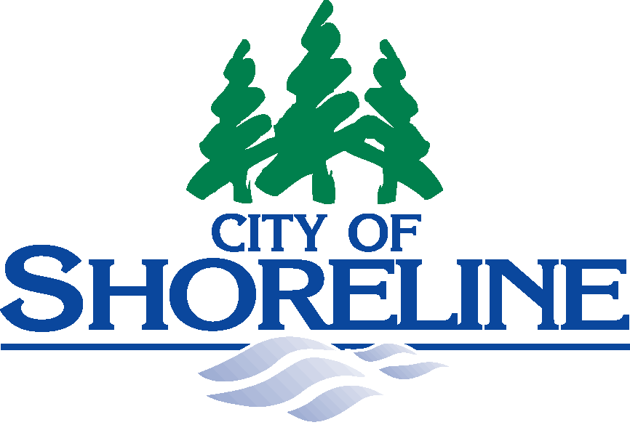 |  | 17500 Midvale Avenue North  Shoreline, Washington 98133-4921  Agenda Line (206) 801-2236

PLANNING COMMISSION COMMITTEE
MEETING NOTICE
As required by RCW 42.30, the Open Public Meetings Act,
you are hereby notified of the meeting schedule for the Shoreline Planning Commission Committee
on Light Rail Station Area Planning.

What: |  | Planning Commission Committee  for Light Rail Station Area Planning
When: |  | Third Thursday of Each Month  4:00 – 5:00 p.m.  Thursday, November 21, 2013  Thursday, December 19, 2013  Thursday, January 16, 2014  Thursday, February 13, 2014  Disclaimer: standing meetings may be canceled due to Commissioner availability, please call Miranda Redinger at  (206) 801-2513 to confirm schedule.
Where: |  | Shoreline City Hall – Salish Room 107  17500 Midvale Avenue North  Shoreline, WA 98133
Public Comment: |  | While Committee meetings are open to the public, the meetings do not allow opportunity for public comment. However, the public is invited to give comment at regular Planning Commission meetings.
Committee Reports: |  | The Committee will report back to the full Commission at its next regularly scheduled meeting (the 3rd Thursday of each month).

