City of Shoreline Public Art Collection
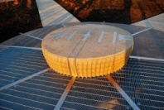 | 1. Reflex Solaris, Laura Haddad and Tom Drugan, artists concrete, steel, and sun  Richmond Beach Saltwater Park 2021 NW 190th St.  City of Shoreline 1% for Art Program 2009
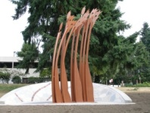 | 2. Contemplating the Arc  Stuart Nakamura, artist  concrete, stone, and steel  Echo Lake Park on Ashworth Ave N/Interurban Trail at N 199th St.
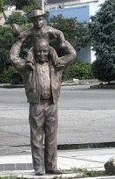 | 3. Parade Route,  Chris Bennett, artist  cast bronze  North City neighborhood on 15th Ave NE at NE177th St, NE corner  City of Shoreline 1% for Art Program 2007
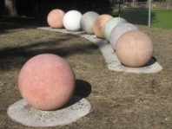 | 4. Dew Beads,  Kristin Tollefson, artist  colored concrete with aggregate, concrete, glass and stones  Hamlin Park 16006 – 15th Ave NE  City of Shoreline 1% for Art Program 2010
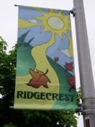 | 6. Ridgecrest Banners, Adam Yaw, artist  digital printed fabric  Multiple locations on 5th Ave. between 150th and 165th, and at Ridgecrest School parking lot on 10th Ave NE just north of 165th St.  City of Shoreline Neighborhood Mini-Grant 2008
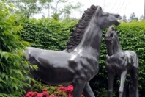 | 7. Ponies, artist unknown  cast bronze  Ronald Bog Park 2301 N 175th St.  Anonymous Donation 1998
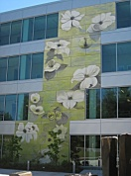 | 8. Limelight, Linda Beaumont, artist  paint on aluminum  Shoreline City Hall 17500 Midvale Ave N
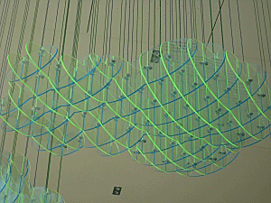 | 9. Cloud Bank, Leo Saul Berk, artist  acrylic and vinyl coated steel  Shoreline City Hall lobby 17500 Midvale Ave N  OPUS Northwest LLC design-build 1% construction funds 2009.
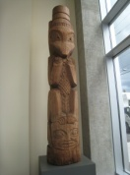 | 10. Totem Pole, Dudley Carter, artist  carved wood and paint  Shoreline City Hall lobby 17500 Midvale Ave N  Anonymous Donation 1998
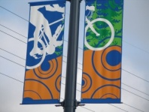 | 11. Aurora Banners, Jessica Amoateng, artist  silk-screen print on fabric  32 poles on Aurora Ave between N145th St & N 165th St  City of Shoreline 1% for Art Program 2007
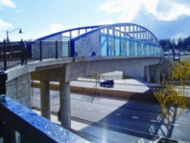 | 12. Interurban Trail Bridges, Vicki Scuri, artist  concrete, steel, glass, light and greening  155th Ave N at Aurora Ave N and Aurora Ave N at 160th  City of Shoreline 1% for Art Program 2007
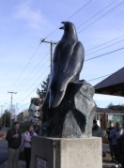 | 13. Emissary Raven, Tony Angell, artist  cast bronze  Interurban Trailhead, N 145th St & Linden Ave N  Donation by Rotary of Shoreline, Shoreline Rotary Foundation and individual Rotary members 2005
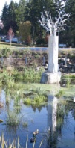 | 14. Raintree, Kristin Tollefson, artist  aluminum, glass & concrete  Photo by Kristin Tollefson  Cromwell Park, 18030 Meridian Ave N  City of Shoreline 1% for Art Program 2010
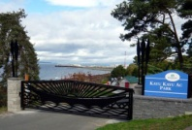 | 15. Traveling Traditions on the Salish, David Franklin, artist  steel, stone and paint.  Photo by David Franklin  Kayu Kayu Ac Park, 19911 Richmond Beach Drive NW
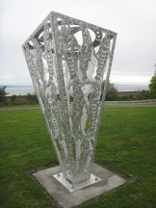 | 15. Salmon Hunt, James Madison, artist  aluminum  Kayu Kayu Ac Park, 19911 Richmond Beach Drive NW  King County Brightwater Mitigation Program and the City of Shoreline 2010
Art in Shoreline's Public Places
Owned by Other Entities

Neighborhoods:
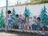 | A. The Children, Echo Lake neighborhood wall mural, Shay Thoelke  artist acrylic paint on cement  Holyrood retaining wall 1st Ave NE & Ballinger Way NE Holyrood Cemetery and the Echo Lake Neighborhood Association 1998
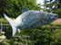 | B. Salmon, Victoria Gilleland, artist, and students  mixed media on fiberglass  Einstein Middle School 19343 – 3rd Ave NW Shoreline-LFP Arts Council Artist in Residence Program
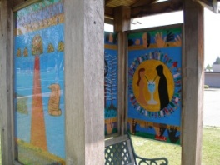 | C. Edwin Pratt Memorial, Stuart Nakamura, Marguarita Hagan and Marsha Lippert, artists  mixed media three part installation: stepping stones, plaque and kiosk murals Shoreline Center Soccer Fields 1st Ave NE at 188th Shoreline-LFP Arts Council Artist in Residence Program 1996, 1998, 2000
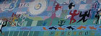 | E. Mural., Mauricio Robalino, artist & students 1992  paint on wood  Parkwood Elementary School 1815 N 155th St
King County Library System:

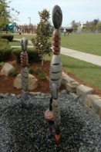 | G. Stoneman Family., Barry Namm, artist stone fountain Richmond Beach Library 19601 21st Ave NW King County Library System Foundation & Friends of the Richmond Beach Library
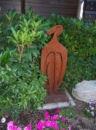 | G. Woman Sitting., Sandra Zeiset Richarson, artist  cut steel  Richmond Beach Library 19601 21st Ave NW  King County Library System Foundation & Friends of the Richmond Beach Library
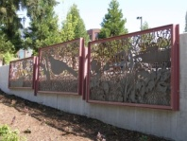 | H. The Sea Beside Us., Deborah Mersky, artist  laser-cut steel panels  Shoreline Library 345 NE 175th  King County Library System 2007
Shoreline Fire District:
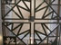 | I. Shoreline Fire Dept. Training Center, window and interior pieces,  Stuart Nakamura, artist  Etched glass window painted wood reception desk treatment - Hand-cut aluminum skylight  17525 Aurora Ave N  Shoreline Fire Department Collection 2002
King County Public Art Collection, managed by 4Culture:
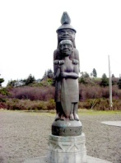 | J. Welcoming Figure, Steve Brown, Andy Wilbur, Joe Gobin, artists  cast bronze  Richmond Beach Saltwater Park  2021 NW 190th St  King County Public Art Collection, managed by 4Culture 1998
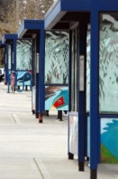 | K. Raven and Pheasant: Reflections of Echo Lake by Stuart Nakamura, artist  steel and paint: bus shelters, railings and structure exterior works  Aurora Village Transit Center  N 200th at Ashworth Ave N  King County Public Art Collection, managed by 4Culture 2002
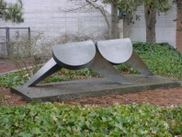 | L. Gnomon, Richard Goss, artist  cast bronze.  Shoreline Pool, 19030 1st Ave NE  King County Public Art Collection, managed by 4Culture 1976
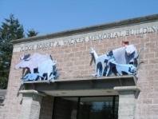 | M. The Jury, Lynn DiNino, artist  painted aluminum  King County Court House18050 Meridian Ave N (Shoreline District Court entry)  King County Public Art Collection, managed by 4Culture 1992
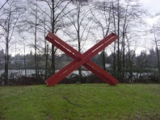 | N. The Kiss, Michael Sweeney, artist  cor-ten steel  2301 NE 175th St, Ronald Bog Park,  King County Public Art Collection, managed by 4Culture 1978
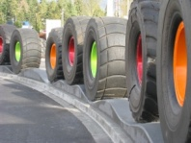 | O. Re-Tire, Carolyn dePelecyn, artist  re-cycled tires and Dale Stammen, sound
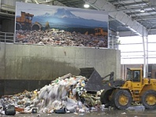 | Terra Firma, Carolyn dePelecyn, artist  photograph  Photos by Steve McGehee  Shoreline Transfer Station, 2300 N 165th St  King County Public Art Collection, managed by 4Culture 2007
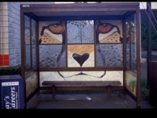 | P. Cheetah, Lynn Turnblom, artist with Meridian Park Elementary students  paint on wood panels  Bus shelters: Ballinger Way NE just east of 15th Ave NE  Shoreline-LFP Arts Council Artist in Residence Program  King County Public Art Collection, managed by 4Culture 2001
Washington State Arts Commission Collection:
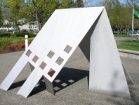 | Q. Back and Forth, Jean Mandeberg, artist  aluminum.  Washington State Public Health Lab – 1610 N 155th St  Commissioned by the Washington State Arts Commission in partnership with the Department of Social and Health Services  WSAC Collection 1986
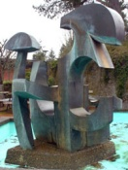 | F. Water, Light & Shade, Drex Adkison, artist  bronze fountain.  Shoreline Community College 16001 Greenwood Ave N  Commissioned by the Washington State Arts Commission in partnership with Shoreline Community College 1977
F. Out of Nature, Deborah Mersky, artist
bronze wall mural
Commissioned by the Washington State Arts Commission

